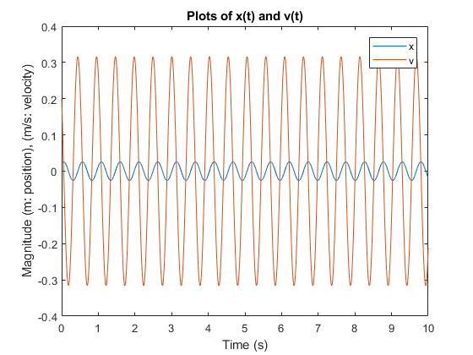

m = .2; % mass in kg

k = 30; % spring constant in N/m

w = (k / m)^0.5; % angular freq

B = .02; % constant1 in m

C = .01633; % constant2 in m

t = 0:0.01:10; % domain of graph

x = B\*cos(w\*t) + C\*sin(w\*t);

v = -1 \* w \* B \* sin(w\*t) + w \* C \* cos(w\*t);

plot (t, x, t, v);

title('Plots of x(t) and v(t)');

xlabel('Time (s)');

ylabel('Magnitude (m: position), (m/s: velocity)');

legend('x', 'v')